Types of Subjects
# Source: AI Source: Provided by: [Data Path: Persons Table -> ID Column: 1, Name_En Column: Motasem Essam] -> From: [Chatgpt (GPT-4-turbo)] on [8/4/2025]
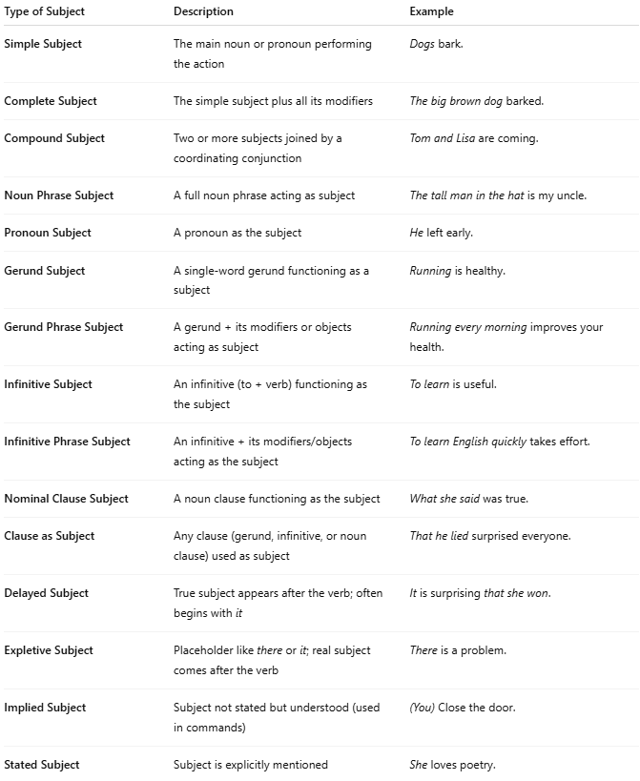

Type of Subject | Description | Example
Simple Subject | The main noun or pronoun performing the action | Dogs bark.
Complete Subject | The simple subject plus all its modifiers | The big brown dog barked.
Compound Subject | Two or more subjects joined by a coordinating conjunction | Tom and Lisa are coming.
Noun Phrase Subject | A full noun phrase acting as subject | The tall man in the hat is my uncle.
Pronoun Subject | A pronoun as the subject | He left early.
Gerund Subject | A single-word gerund functioning as a subject | Running is healthy.
Gerund Phrase Subject | A gerund + its modifiers or objects acting as subject | Running every morning improves your health.
Infinitive Subject | An infinitive (to + verb) functioning as the subject | To learn is useful.
Infinitive Phrase Subject | An infinitive + its modifiers/objects acting as the subject | To learn English quickly takes effort.
Nominal Clause Subject | A noun clause functioning as the subject | What she said was true.
Clause as Subject | Any clause (gerund, infinitive, or noun clause) used as subject | That he lied surprised everyone.
Delayed Subject | True subject appears after the verb; often begins with it | It is surprising that she won.
Expletive Subject | Placeholder like there or it; real subject comes after the verb | There is a problem.
Implied Subject | Subject not stated but understood (used in commands) | (You) Close the door.
Stated Subject | Subject is explicitly mentioned | She loves poetry.

